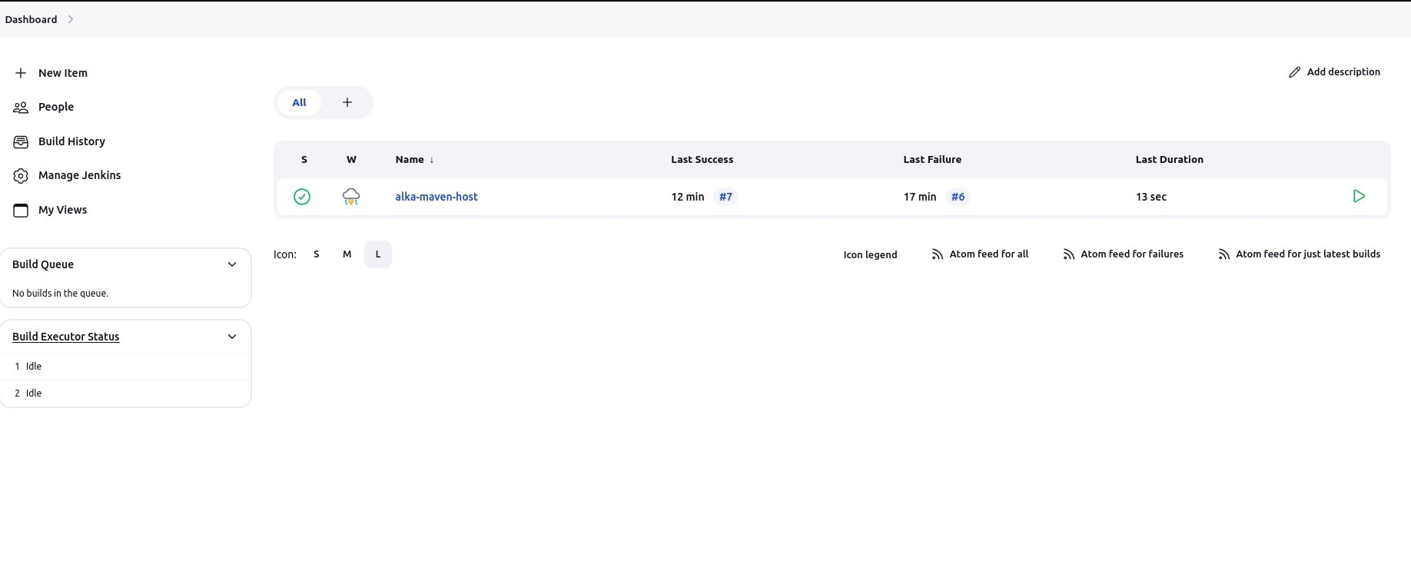**Assignment no:02**



